

The back of the badge should always be touching you.

The front of the badge should always face outwards towards the source of radiation

at all times. The white plastic should be facing the outward

on the underside of your finger. The ring opening should

be worn on the upper-side of your finger.

Try to wear the ring on your dominant hand on your finger each time.

It is very important for you to wear your badge so that your name is facing outward. There is a small oval on the front of the badge and this should be facing the source of radiation as much as possible to ensure the badge is providing the most accurate dose reading.

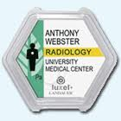 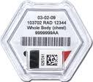

For all body badges, you can see the location on your body where your badge should be worn by looking at the little white dot on the human figure on the badge. The white dot indicates where the badge should be worn. For fetal badges, you will see a little picture of a baby to indicate it is a fetal monitor.

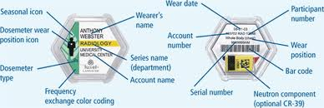

For ring badges, the white plastic with your name etched into it should be facing the source of radiation

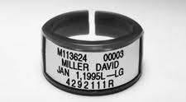

How do I wear my badge?

Using Landauer Badges

FOR QUESTIONS PLEASE CONTACT ENVIRONMENTAL SAFETY AND RISK

Your Name Here

Your Title Here

Street Address

Suite 555

City, State 55555

P: 555-555-5555

E: email@address.com

www.webaddress.com

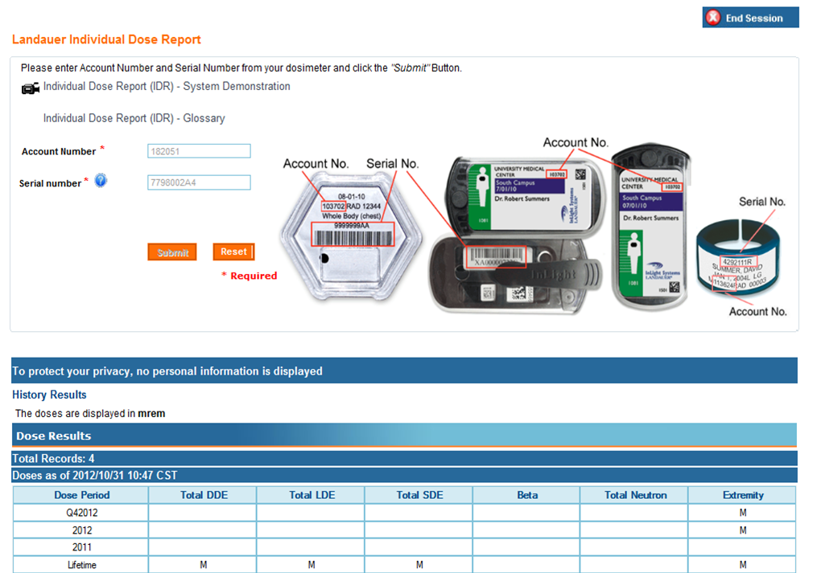

PLACE PHOTO HERE,

OTHERWISE DELETE BOX

Individual Dose Reporting (IDR)

Landauer Individual Dose Reporting (IDR) allows all badge program participants to use the same group user name and password to login to myLDR.com to obtain their most recent badge reading, QTD, YTD, and Lifetime to date cumulative dose histories.

Participants’ identifying information is not used at all for the login or to obtain readings. After login, the participant is prompted to enter UNM’s account number, 706219, and then the serial number of the badge they are currently wearing.

The system will then query their last-read doses and provide a screen shot without providing any other type of identifier as to the “owner” of that dose.

|  |  |
| --- | --- |
| Use | Description |
| AREA | Area monitor |
| CHEST | Chest |
| CNTRL | Control |
| COLLAR | Collar |
| FETAL | Fetal |
| LFINGR | Left Ring Finger |
| RFINGR | Right Ring Finger |
| WAIST | Waist |
| WHBODY | Whole Body |

Landauer Luxel+ badges can measure X, Gamma, Beta, and Fast/Thermal Neutrons* (*requires CR-39 Ja badge)

Landauer TLD Ring badges can measure X, Gamma, and Beta

How can I check my dose?

It is important to understand your annual exposure limits. Radiation detection monitors are used as a means to monitor the amount of radiation you are exposed to while performing your job. We are required by both the State of New Mexico and the University to ensure your exposures do not exceed the maximum annual limits set below.

ANNUAL EXPOSURE LIMITS (in mrem):

|  |  |
| --- | --- |
| Whole Body, blooding forming organs, gonads | 5,000 |
| Lens of Eye | 15,000 |
| Extremities and Skin | 50,000 |
| Fetal (gestation period) | 50 |

Exposure Limits

.

Badge Abbreviations